Morning,

A quick run down of the numbers before a look at the content this week.

Numbers have been good over the weekend, which follows on from a pretty slow start to the week before it picked up around Wednesday.

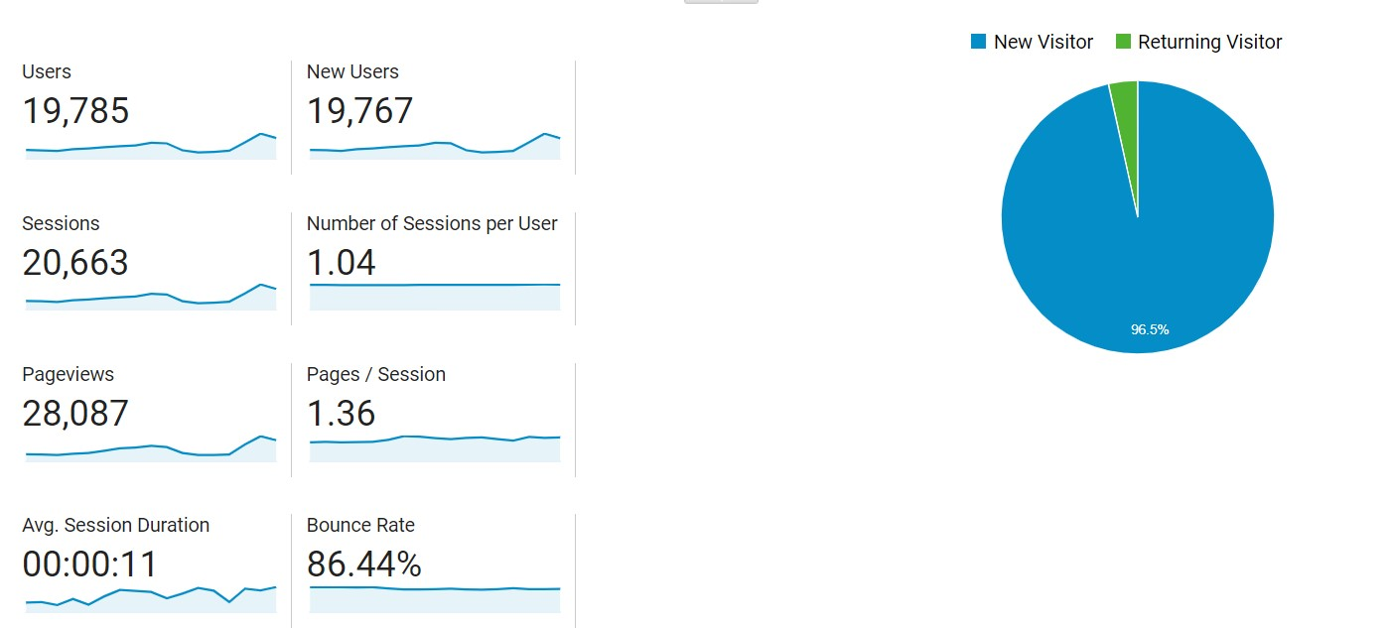

Saturday and Sunday both saw us break the 2K mark, another landmark and putting us in a nice position as we come into the last two weeks of the month.

Google organic traffic is trending upwards and the last six days have seen over 100 users from this. It now accounts for over 8% of our traffic.

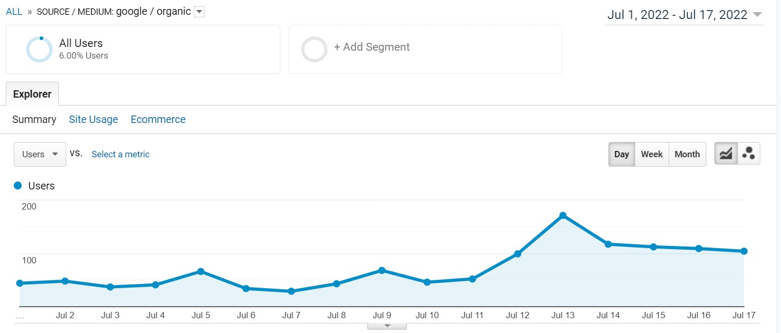

This week is a bit slow on new releases/updates but that just gives us more opportunity to focus on longtail evergreen etc. There is a tendency for a few things to pop out the woodwork on Monday too, so stay vigilant to breaking news.

Monday:
Wild Rift new weekly challenges

Tuesdays:
Pharoah’s Cup
PUBG Ultimate Skin

Wednesday:
Wild Rift free champion rotation
Day 4 ESL Brawl Stars EU & MENA
Free Fire Weekly Schedule

Thursday:
Potential release of new Asphalt 9 track
Mirror Deck Challenge Clash Royale

From tomorrow we have 14 days to smash our targets and show ESL why they made the right decision in partnering with us.

Videos:

Currently, there are no videos on the website. Ivan can speak more to this but I believe there has been a few things that have held that up. I believe we have Thomas for an hour a day?

Let’s discuss in the meeting and get the ball rolling on this. (I have invited Thomas to the meeting).

Social Media Updates

